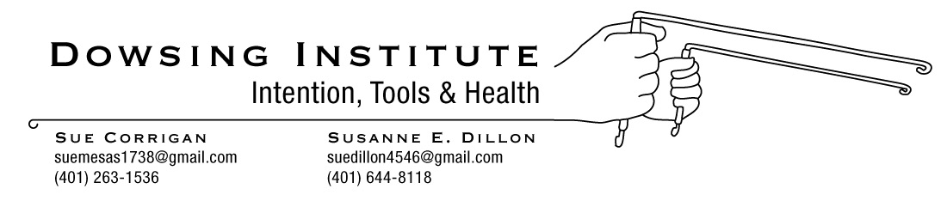

Are you aware we are all capable of being healers?

When two or more people come together to pray or send healing energy to a person or a situation, it is greatly intensified. Our words and thoughts are very powerful, especially when directed to a particular intention.

A universal way to word our intention is to say ‘for the Highest and Best, more than we could ever imagine’ for whoever or whatever the intention is meant for.

You are encouraged to do the above with your family and/or friends often.

You are welcome to come to Sue Corrigan and Susanne Dillon’s Power of Eight Healing sessions on the 2nd Saturday of the month, 2:00pm, at It’s My Health, 1099 Mendon Road, Cumberland, RI http:Its-my-health.com

This work is based on the book ‘The Power of Eight” written by Lynne McTaggart. Lynne facilitates two healing sessions weekly on Facebook. Visit her website LynneMcTaggart.com for more information.

